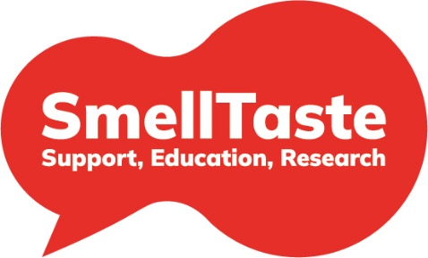
SmellTaste Policy on working with the Pharmaceutical Industry

People affected by smell and taste disorders (SATDs) have been overlooked for a long time, with limited access to specialist clinical care and support and a lack of research into understanding the causes and developing new treatments. There is a significant lack of recognition of the scale and impact of these sensory impairments amongst public, health services and policymakers. SmellTaste is committed to securing long-term improvements in patient care and support, education for professionals and research into developing effective treatments for all those all those affected by SATDs, whatever the cause of their sensory impairment.

SmellTaste wants to ensure that:
- Everyone affected by a SATD has access to a specialist smell and taste clinic with smell testing, early diagnosis and continued support
- Smell testing is routinely undertaken in public health settings to identify all those who need support, information and care
- All health and social care professionals have access to education and training on SATDs
- There is a significant increase in funding for vital research to improve our understanding of the causes of smell and taste dysfunction, develop much-needed new treatments, and find new ways of helping people live well with their condition
- There is a significant increase in recognition of the impact of smell and taste disorders on our health, wellbeing and safety by the government, public and private sectors
- All those affected by a SATD should receive information about emerging research studies, clinical trials and new services with the opportunity to participate in clinical trials looking at their specific condition

Given the scale of the gaps/problems faced, SmellTaste recognises it needs to work in partnership with other organisations from the public, commercial and third sectors to accelerate progress and to generate the funds to drive research, clinical services and support. We are stronger when we work together towards shared goals.
SmellTaste will always apply due diligence when working in external partnerships and will record and report all donations and gifts received each year.

SmellTaste will be especially concerned to maintain its independence when entering into a financial relationship with a commercial organisation and any such relationship will require approval by the Board of Trustees and be reported each year. SmellTaste is committed to being transparent about these relationships and the use of any funding received from commercial organisations.

SmellTaste is aware of and fully supports the policies set out in the Code of Practice of the Association of the British Pharmaceutical Industry particularly those relating to relationships between patients' organisations and the pharmaceutical companies. We take a similar approach in working with biotech companies.

It is important to note that commercial organisations are just one group that SmellTaste works with. SmellTaste is committed to working with and encouraging other external organisations - including government departments, the NHS and statutory agencies - to develop, invest in and deliver services, educational programmes and research in the field of SATDs.

